Project Development Phase
Model Performance Test

Date | 27 June 2025
Team ID | LTVIP2025TMID43276
Project Name | Clean Teach: Transforming Waste Management with Transfer Learning
Maximum Marks

Model Performance Testing:
Project team shall fill the following information in model performance testing template.
S.No. | Parameter | Values | Screenshot
 | Model Summary | A CNN-based model was used with multiple convolutional, pooling, and dense layers. The model accepts 224x224x3 input and outputs 3 waste categories. | 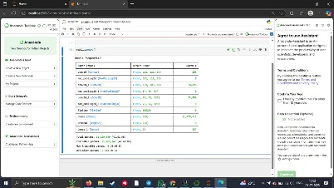
 | Accuracy | Training Accuracy – 91%  Validation Accuracy -98% | 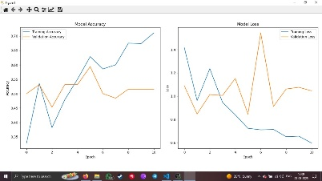
3. | Fine Tunning Result( if Done) | Validation Accuracy -89% | 

